METHODS YEAR 12 Test 3 2017 Name:________________________
Anti-Differentiation
Resource Assumed Time: 25 minutes Marks: / 25
CAS calculator + A4 page 1 side of notes

Question 8 (8 marks)
Sam has invested $A in a fund which compounds her investment continuously at a rate of k % per annum.
The rate of change of her investment is given by where V is the value of her investment in dollars and t is the time in years.
The net change in the value of her investment in the first 10 years is $12 331 . 78.
The net change in the value of her investment in the next 10 years is $22 469 . 97.
- Determine the values of A and k. (6 marks)

- Hence determine the function that defines the value of her investment.
(2 marks)
Question 9 (6 marks)

Calculate the shaded area shown below, showing all relevant working.
(Round both your boundaries and your final answer to 2 decimal places.)
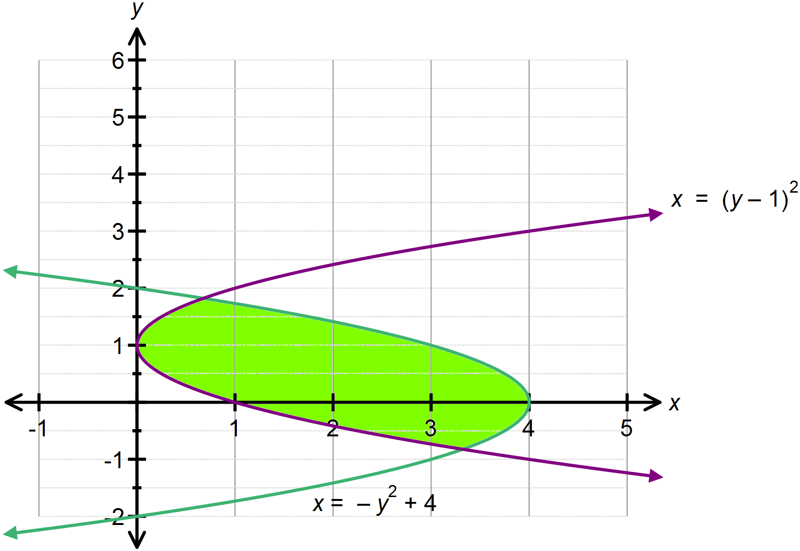

Question 10 (4 marks)
Show that $\int_{1}^{2}{\left(\frac{6x+4}{\sqrt{x}} \right) dx}=16 \sqrt{2}-12$.
(Show sufficient work out please and use exact values)

Question 11 (3 marks)

The area under the curve over the domain is .
Determine the value of k , given that $-1≤k≤1$.

Question 12 (4 marks)
The area bound by the parabola $y=6x^{2}-6x,$ the $x$ – axes and the lines $x=1$and
$x=c, (c>1)$ is equal to 1unit². Find the value of the constant $c$.

END OF PAPER 2
EXTRA PAGE FOR WORK OUT

